Tutorial

## Part 1: OLTP and OLAP

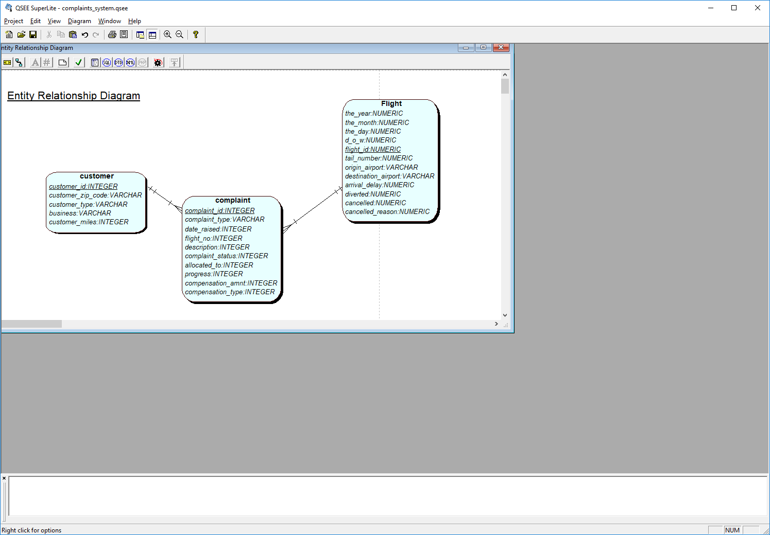

**Aim:** To appreciation differences of Operational Database and DW database types

Undertake the following exercise from the perspective of someone who works in **FlyU customer complaints**

1. Write down 3 queries (reports/things) the consultant may find out from the system. To get a range of query types (INSERT/SELECT/UPDATE/DELETE), try selecting at least:
2. Consider how many tables were used for the query, how recent is the data retrieved, how long would the query take to run, how often this query (or very similar is run)?
3. Now repeat the exercise from the perspective of the FlyU Director
4. Write down 3 queries (reports/things) the owner of ProjectIT can find out from the system/s system and spreadsheets
5. Consider how many tables were used for the query, how recent is the data retrieved, how long would the query take to run, how often this query (or very similar is run)?
6. One of these systems is OLTP the other OLAP – identify! This will depend on you having understood the day to day requirements verses the high level ‘business’ analysis.

Recap/complete: (write OLAP or OLTP) against the characteristic.

|  |  |
| --- | --- |
| High volume (number of records) | Low volume |
| Low volatility – changing of data | High Volatility |
| Designed for daily users of the database system | Designed for management to investigate business patterns |
| Predictable queries | As and when queries |
| Current data | Historical data |
| Designed around transactions | Designed around reports |
| Data maintained constantly | Data maintained as scheduled |
| The nature of the data: granularity? Access? |  |
|  |  |
|  |  |

Any more …?

Let’s discuss – what you have met already, look at some online DW - NHS

## Part 2: Read paper

Found on x-stream > module materials> week 1> Seven Key Interventions for DATA WAREHOUSE SUCCESS *by* By Tim Chenoweth, Karen Corral, and Haluk Demirkan.

Discuss and list important factors to consider when creating a data warehouse.

## Part 3: Research on what is dw future, changes and challenges

## Part 4: Practice writing SQL.

Write code to:

1. Run FlyU set up script (probably done already)
2. Create a new database table: ‘complaints_by_week’ with attributes: Week_no, year, no_of_complaints. We want this table to start recording the number of flights each week.
3. Look at the data you have been given (from the FlyU scripts) and work out what data will be in the table.
4. Write SQL to SELECT the data to put into the table.
5. Write SQL to INSERT the data into the table.

Extra Chellenge:

1. Is the SQL code you have written above re-runable?
   1. Does it work if run again?
   2. Does it reinsert the same data? – it shouldn’t!
2. Do further testing, add more rows to the original tables and re-test your queries.

YYou could use the below, to test if your script can cope with new data being added to the operational dataset.

INSERT INTO FlyU_flights VALUES ('2016','1','3','6','291','N3GYAA','JFK','AUS','883','0','0','');

INSERT INTO FlyU_flights VALUES ('2016','1','3','6','2314','N3LCAA','JFK','BOS','128','0','0','');

INSERT INTO FlyU_flights VALUES ('2016','1','4','7','1096','N3DJAA','JFK','BOS','104','0','0','');

INSERT INTO FlyU_flights VALUES ('2016','1','4','7','291','N3KHAA','JFK','AUS','107','0','0','');

INSERT INTO FlyU_flights VALUES ('2016','1','4','7','2314','N3DJAA','JFK','BOS','114','0','0','');

INSERT INTO FlyU_flights VALUES ('2016','1','6','2','2314','N3JYAA','JFK','BOS','144','0','0','');

INSERT INTO FlyU_flights VALUES ('2016','1','7','3','291','N3GPAA','JFK','AUS','119','0','0','');

INSERT INTO FlyU_flights VALUES ('2016','2','3','2','1096','N3CMAA','JFK','BOS','138','0','0','');

## Part 5: Upload the weather excel spreadsheet